**CONTACT**

**Address:**

Block 3 aman residency, karachi

**Phone:**

+92 3161611907

**Email:**

Ifham.khan105@gmail.com

**LANGUAGES**

English

Urdu

**IFHAM AHMED KHAN**

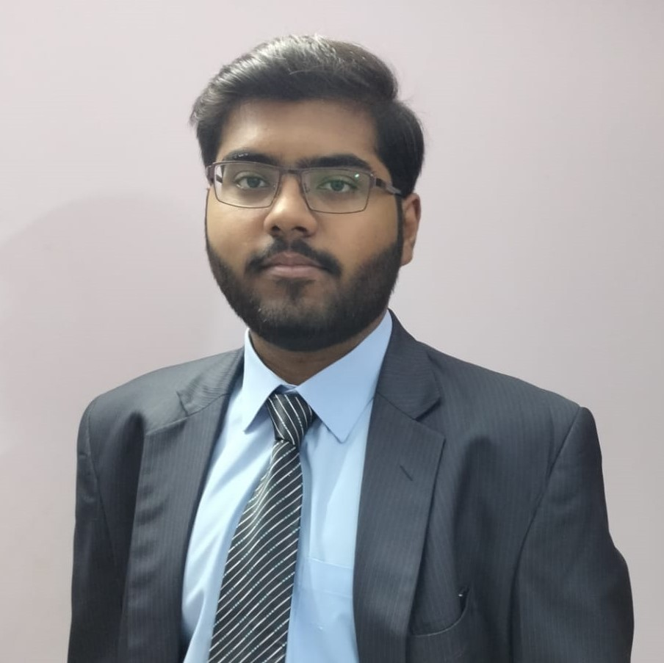

**OBJECTIVE**

To take a challenging and managerial role in the field of Computer programming and implement the expertise and experience that I will gain in this field to develop complex project with efficiency and good quality.

**WORK EXPERIENCE**

|  |  |
| --- | --- |
| * Not yet |  |

**EDUCATION**

Started in 15/8/2020

* Doing: Bachelor Degree of Computer science, from Mohammad Ali Jinnah University Karachi.
* Fourth semester (CGPA: 3.28)

Completed in 14/2/2020

* Intermediate in Computer Science, from Govt. Jinnah College Karachi

Completed in 6/8/2017

* Matric, Farah model school Karachi

**ADDITIONAL SKILLS**

* Programming languages: Kotlin, C#, C language, JAVA, JAVA Script, CSS, HTMl, python (basic).
* MS Word, MS Excel, MS Power point, MS Project, MS access, MS visio, MS SQL server, Video editing, Picture editing, Cisco packet tracer.
* Prototyping on (JustInMind and Balsamiq)
* Web designing (Wordpress/Wix) and app development (Android studio)

**REFERENCES**

Reference available on request